CHAPTER 3
MODELING in the TIME DOMAIN
3.1 INTRODUCTION
2 Approaches for the ANALYSIS and DESIGN of FEEDBACK Control Systems.
- Freq.-Domain (Classical)
Advantages : - RAPIDLY provide STABILITY &Transient Response Information.
Disadvantages : - Can be APPLIED ONLY to LINEAR, Time-Invariant Sys.
- Time-Domain (Modern, State-Space)
+Method for MODELING, ANALYZING, and DESIGNING a wide range of Sys.
+CAN be used to :
- Represent Nonlinear Sys. That have BACKLASH, Saturation, and Dead Zone.
- Sys. With Nonzero Initial Condition.
- Time-Varying Sys.
- Multiple-Input/Output Systems,
Can be represented with a model similar in form and complexity to that used for single input/output Sys.
- Sys. With a Digital Coumputer in the LOOP or to model sys. For digital simulation.
Sys. Response can be obtained for Changes in sys. Parameters – (An important design tool).
- The SAME class of systems modeled by the Classical approach.

3.2 SOME OBSERVATION
Some Following Approach :
- State Variables,
- State Equations,
- If the System has initial condition at ALL Variables, then for the State Variables t ≥ t₀
- Output Equation,
- State-Space Representation

Follow these STEPS for STATE-SPACE…
First-Order System STEPS,
- Select the Current (Direction), i(t),
- Write the LOOP Equation,
- Taking The LAPLACE TRANSFORM, and its INITIAL CONDITION
- SOLVE for all the Other Network Variables ALGEBRAICALLY . The Ouput Equation.
- Solve The STATE-SPACE REPRESENTATION.
Second-Order System STEPS
- First-Order Differential is NEEDED for SOLVE 2 State Variables,
- Writing the LOOP Equation, Converting the State Variable,
- Using the LAPLACE TRANSFORM and the METHOD of CHAPTER 2 (Freq.-Domain)
- Find The Output Equation.
- Solve State-Space Representation

+A Second-Order System REQUIRE a MINIMUM of TWO State Variables to DESCRIBE it,
+The State and Output Equation can be written in VECTOR-MATRIX form, IF THE SYSTEM is LINEAR.
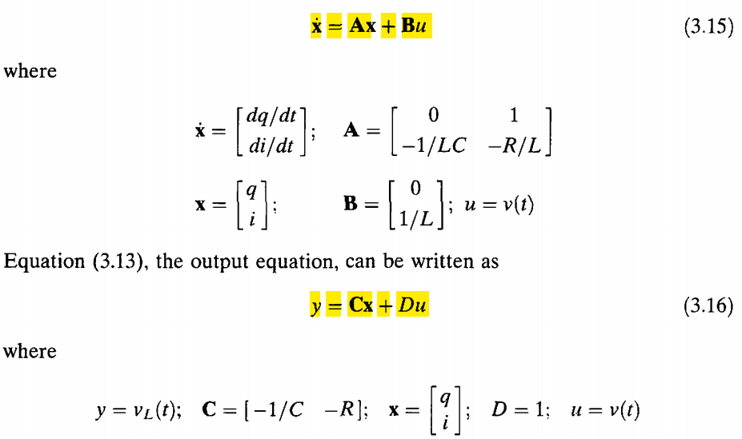

3.3 THE GENERAL STATE-SPACE REPRESENTATION
+Formalize for SOME Definitions;
- Linear Combination, 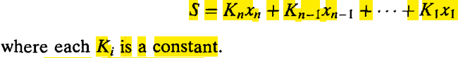
- Linear Independence,
(Var. X_{i}, for i = 1 to n) = LINEARly Independence; their S = 0 ⇔ every K_{i} = 0 and NO X_{i} = 0 for ALL t ≥ 0.
- Sys. Variable, any var. that RESPONDS to an INPUR or INITIAL COND.,
- State Variable,
- State Vector, 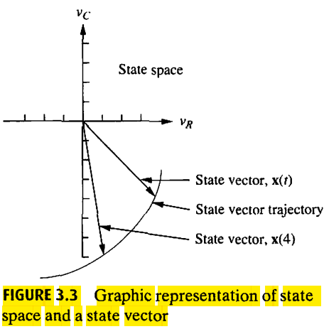
- State-Space,
- State Equation,
- Output Equation
+EQUATION that Represents a System in STATE SPACE ;
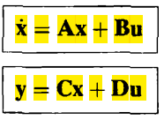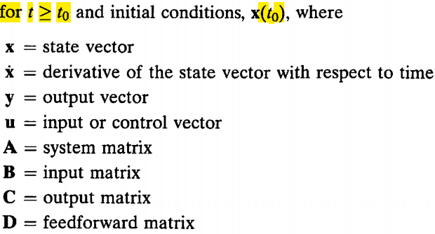
+ As an Example,
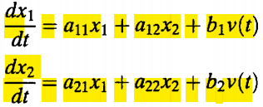with x1 and x2 are the State Variables.
If there are a SINGLE OUTPUT, then
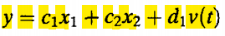

3.4 APPLYING THE STATE-SPACE REPRESENTATION
LINEARLY INDEPENDENT STATE VARIABLES
+The Comp. of the State Vector MUST BE Linearly Independent,
MINIMUM NUMBER OF STATE VARIABLES
+The Minimum Number required equals the Order of the Differential Equation Describing the System,
+ Too FEW the State Variables are SELECTED > it may be IMPOSSIBLE to WRITE PARTICULAR OUTPUT Equations,
+You SELECT the MINIMUM NUMBER of STATE VARIABLES but They ARE NOT LINEARLY INDEPENDENT > you MAY NOT BE ABLE to SOLVE for ALL OTHER SYSTEM VARIABLES
+ we want DISPLACEMENT (other STATE VARIABLES) as an OUTPUT > The DENOMINATOR or Characteristic Equation, has INCREASED ORDER to 2 or The Order Initial T.F. (The PRODUCT of 2 TRANSFER FUNCTION),
+The STEPS for ELECTRICAL NET.:
- LABEL ALL,
- SELECT the State Var.by Writing the Derivative Eq. for ALL (ENERGY-Storage elements),
+ Choose the State Var.as the Quantities that are DIFFERENTED,
- APPLY network THEORY,
- SUBTITUTE the RESULT,
- FIND the OUTPUT Eq., & Representing it to VECTOR-MATRIX form (for the STATE-SPACE Representation)

3.5 CONVERTING A TRANSFER FUNCTION TO STATE SPACE
+Generally, These are the STEPS :
- SELECT a SET of STATE VAR. (Phase Variable)
- CONSIDER the DIFFERENTIAL Equation,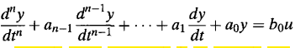
- CHOOSE STATE VAR is to choose the output, y(t) & its (n-1) derivatives as the STATE VAR. (Phase Var. Choice)
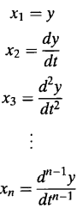
- DIFFERENTING both sides, the dot = differentiation respect to time
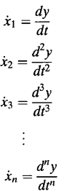
- SUBTITUTING the Definition, the State Eq. are evaluated as
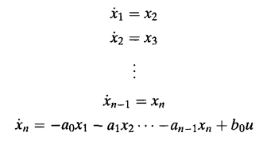
- In VECTOR MATRIX Form,
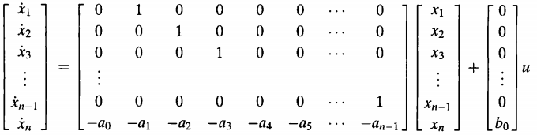
- Since the SOLUTION to Differential Eq is y(t), or x₁, the OUTPUT EQ. is
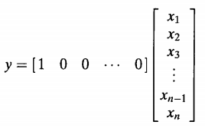
+ZERO >>>Output Eq.
+POLE>>>State Eq.

3.6 CONVERTING FROM STATE SPACE TO A TRANSFER FUNCTION (SS2TF)
+Given The State Eq and Output Eq.
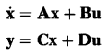
+Formula SS2TF,
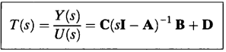
+The STEPS:
- >>>>>>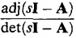
- >>>Formula SS2TF,

3.7 LINEARIZATION
+THE STEPS :
- WRITING the Differential Eq.
- LETTING 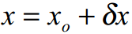
- LINEARIZE X², 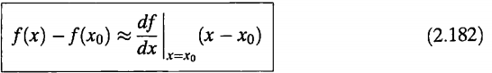
- SUBTITUTING theYIELD of LINEARIZE and DIFFERENTIAL Eq.
- SUBTITUTING the VALUE that DIKETAHUI
- SELECTing the STATE VAR.,
- WRITIING the State and Output Eq.
- CONVERTing to VECTOR-MATRIX form

