Continued
To Handle multiple-node electrical networks, these are following steps:
- Replace, Passive elements values > Their Admittance
- Replace, All Sources & Time Variables > Their Laplace Transf.
- Replace, Transformed voltage sources > Transformed Current sources.
- Write, Kirchhoff’s current LAW at each node.
- Solve, the Simultaneous equations for the output.
- Form, the Transfer Function.
NODAL ANALYSIS -KCL – 2 LOOPs
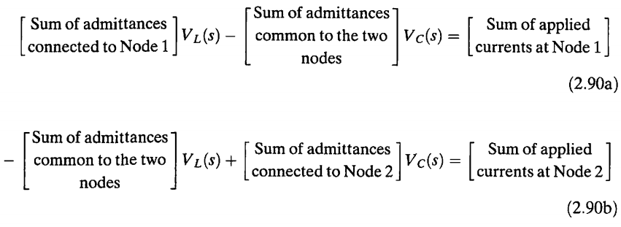
MESH ANALYSIS - KVL - 3LOOPs
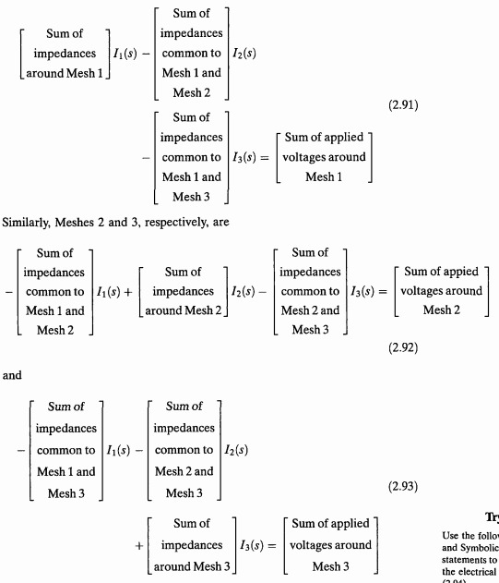
OPERATIONAL AMPLIFIERS (Active Circuits)
E-amplifier used as a BASIC building Block to Implement Transfer Function. SEE FIGURE 2.10(a)
It HAS CHARACTERISTICS:
- Differential INPUT, v2(t)-v1(t)
- HIGH Zin, Zi=Infinite(ideal)
- LOW Zout, Zo=0(ideal)
- HIGH constant A (Gain Amplification), A=Infinite(Ideal)
Output, v0(t)=A(v2(t)-v1(t))
INVERTING OPERATIONAL AMPLIFIER
v2(t)=Grounded=0, SEE FIGURE 2.10(b)
Output, v0(t)= -Av1(t)
SEE FIGURE 2.10(c)
Zin HIGH > KCL, Ia(s)=0 and I1(s)= - I2(s)
A LARGE > v1(t) ≈ 0. Thus, I1(s)=Vi(s)/Z1(s), and I2(s)= - V0(s)/Z2(s)
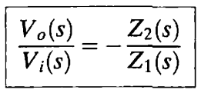
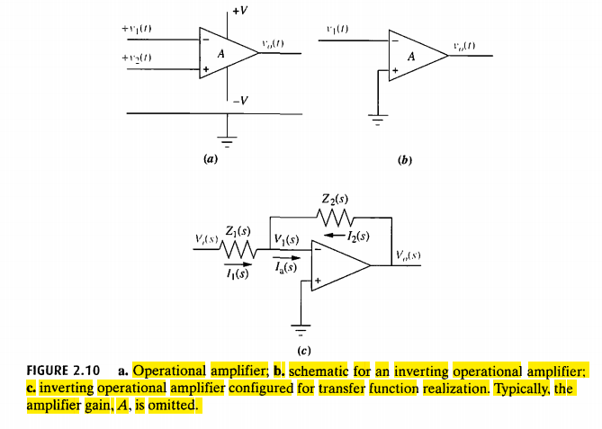
NONINVERTING OPERATIONAL AMPLIFIER
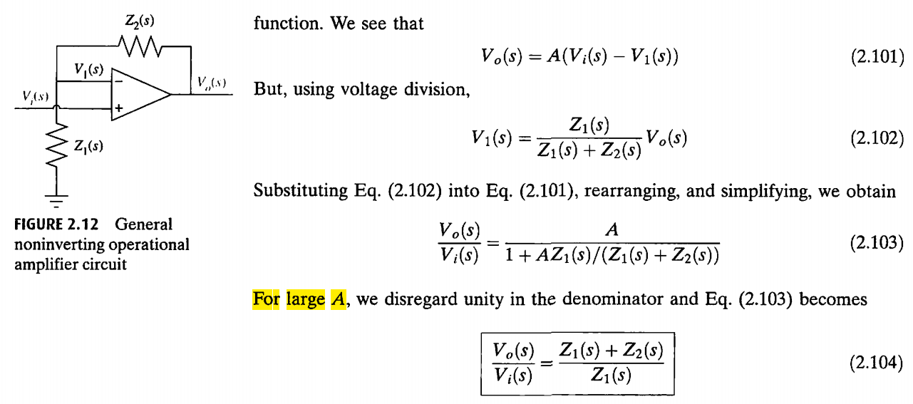
2.5 TRANSLATIONAL MECHANICAL SYSTEM TRANSFER FUNCTION
There are ANALOGIES between ELECTRICAL SYSTEM and MECHANICAL SYSTEM COMPONENT and VARIABLES.
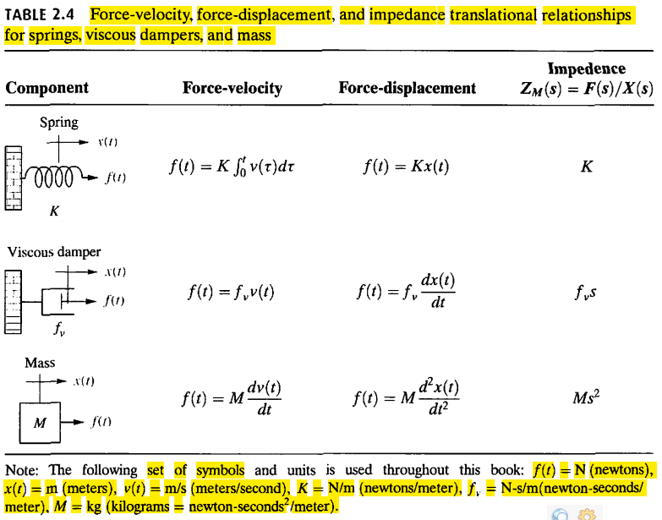
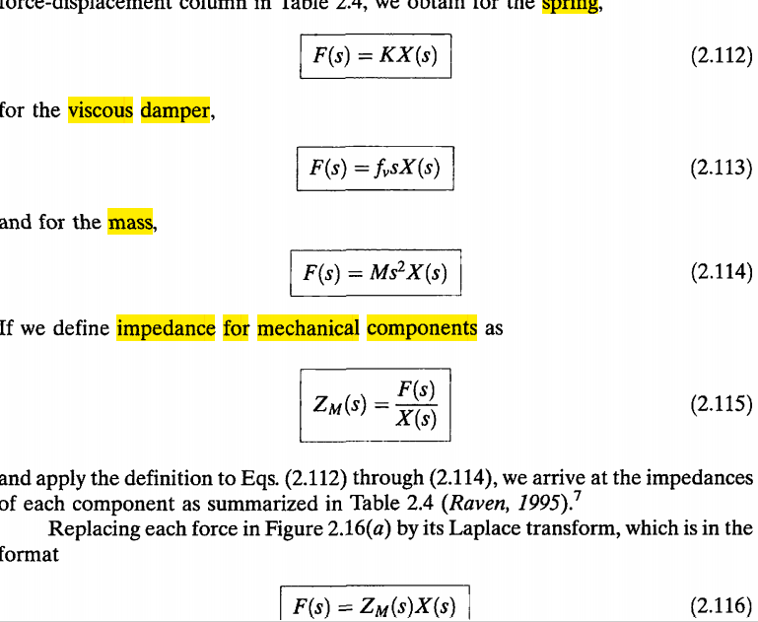
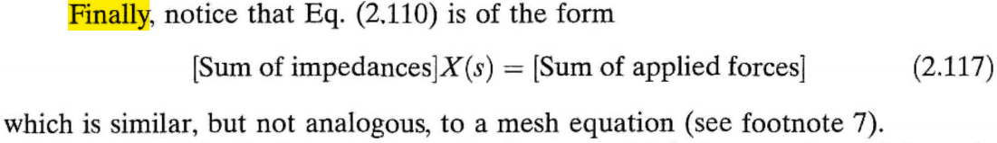
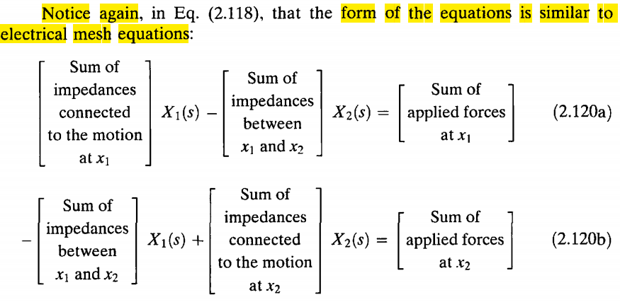

2.6 ROTATIONAL MECHANICAL SYSTEM TRANSFER FUNCTION
Different thing between Translational System and Rotational Mechanical System are
FORCE > TORQUE (F(s) >T(s)), and
Translational Displacement > Angular Displacement (X(s)>θ(s)), and
The Component Undergo Rotational instead Translational

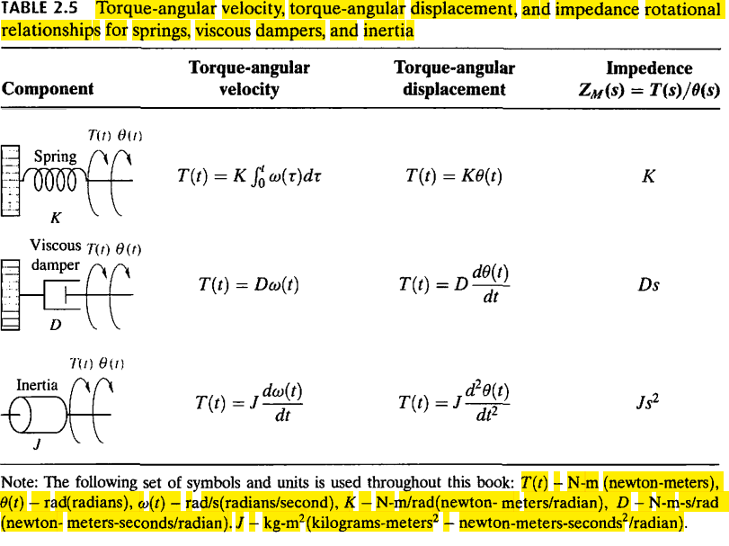
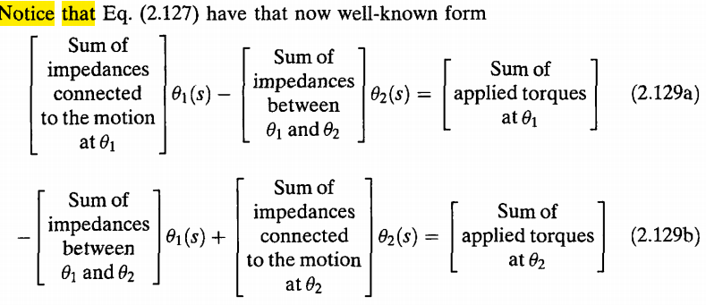
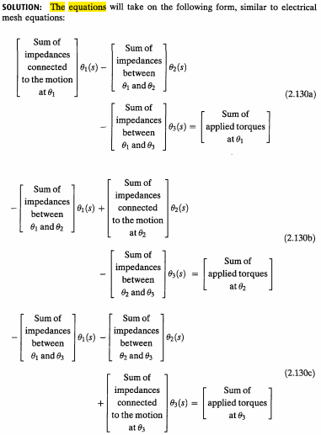

2.7 TRANSFER FUNCTIONS for SYSTEMS with GEARS
+Allow you to MATCH the drive system and the LOAD – a TRADE-OFF speed-torque.
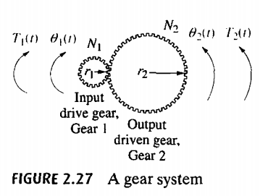
r1θ1=r2θ2
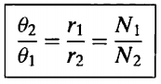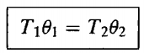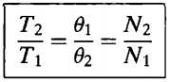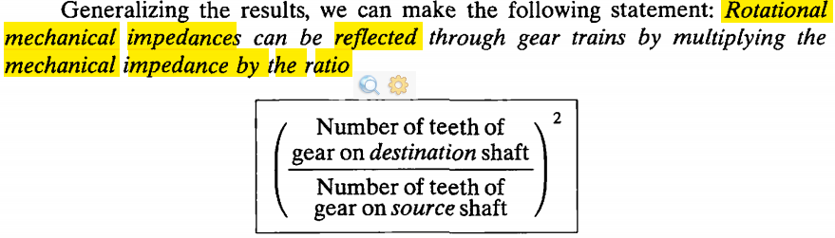
GEAR TRAIN
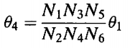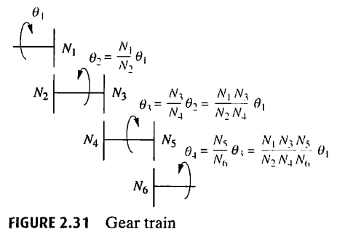
2.8 ELECTROMECHANICAL SYSTEMS TRANSFER FUNCTION
+Hybrids of Electrical and Mechanical Variables.
+MECHANICAL OUTPUT generated by an ELECTRICAL INPUT
+Other Example, Robot Control, Sun and Star Tracker, Disk-Drive position Control.
+MOTOR (an Electromechanical Component) Yields a Displacement Output for a Voltage Input.
+Armatured-Controller DC Servomotor
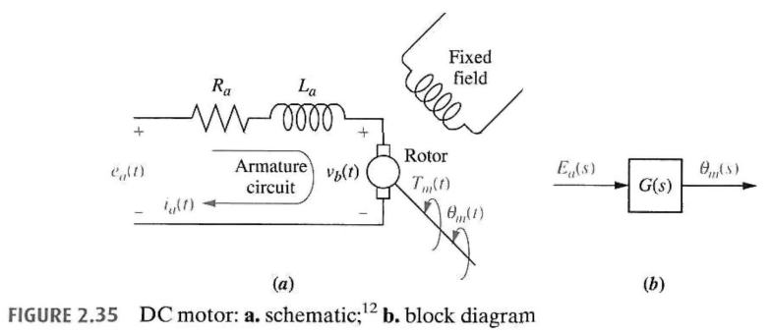
Derivation
Step for FIND the TRANSFER FUNCTION, θL(s)/Ea(s),
- FIND the MECHANICAL Constant, Jm and Dm…
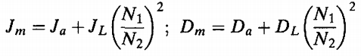
- FIND the ELECTRICAL Constant,
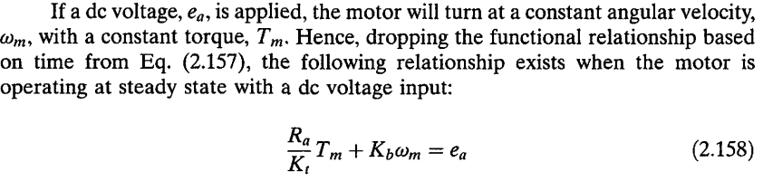
Set ωm=0, to FIND Tstall
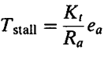
Set Tm=0, to FIND ωno-load
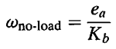
Look Torque-Speed Curve, to FIND Ea
(Electrical Const) Kt/Ra=Tstall/Ea
Kb=Ea/ωno-load
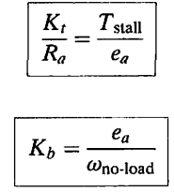
- Subtituting ALL Values into the MOTOR Transfer Function,
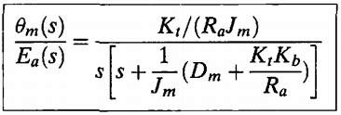
- θL(s)=(gear ratio,N1/N2)xθm(s)

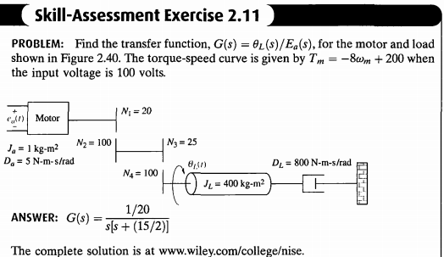
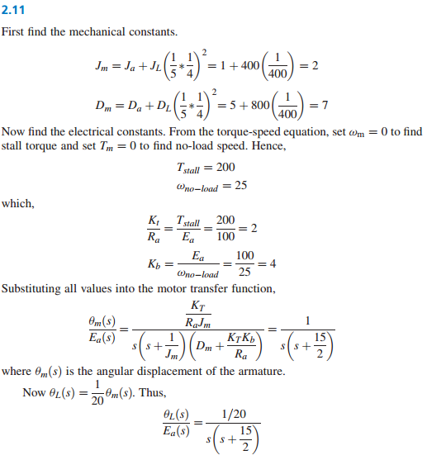

2.9 ELECTRIC CIRCUIT ANALOG
+Electric Circuit Analog, is an ELECTRIC CIRCUIT that is ANALOGUES to a SYSTEM from ANOTHER DISCIPLINE.
+CONVERTING Mechanical System to Electrical Networks
SERIES ANALOG
+USING MESH Equation (KVL)
ELECTRIC Equations
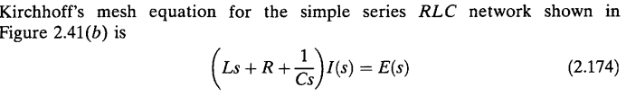
MECHANICAL Equations
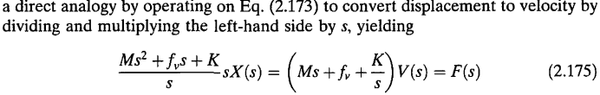
ANALOGUES between Electric Equation and Mechanical Equation
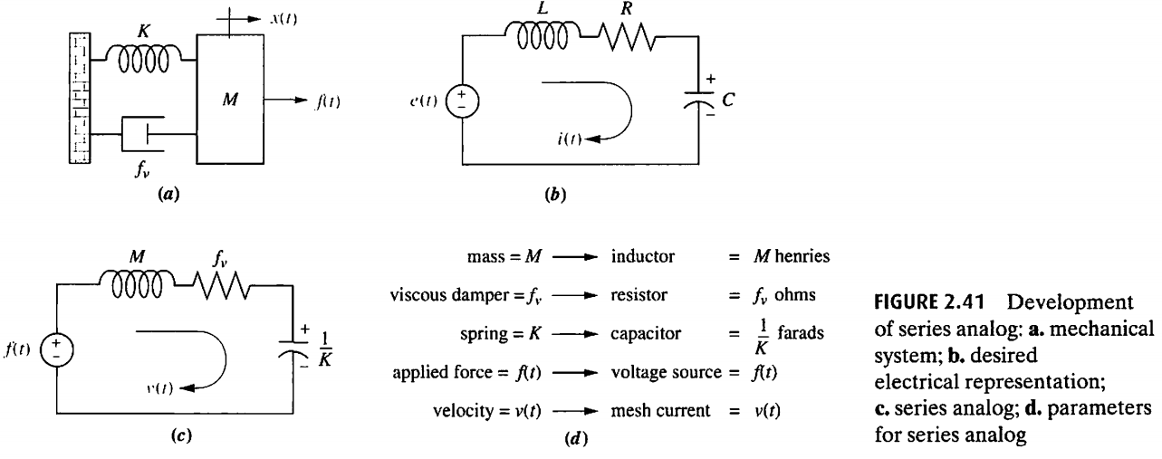

PARALLEL ANALOG
+USING NODAL Equation (KCL)
ELECTRIC Equation
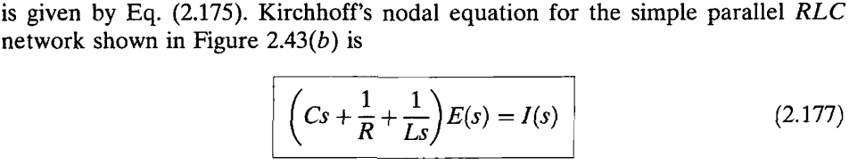
ANALOGUES between Electric Equation and Mechanical Equation
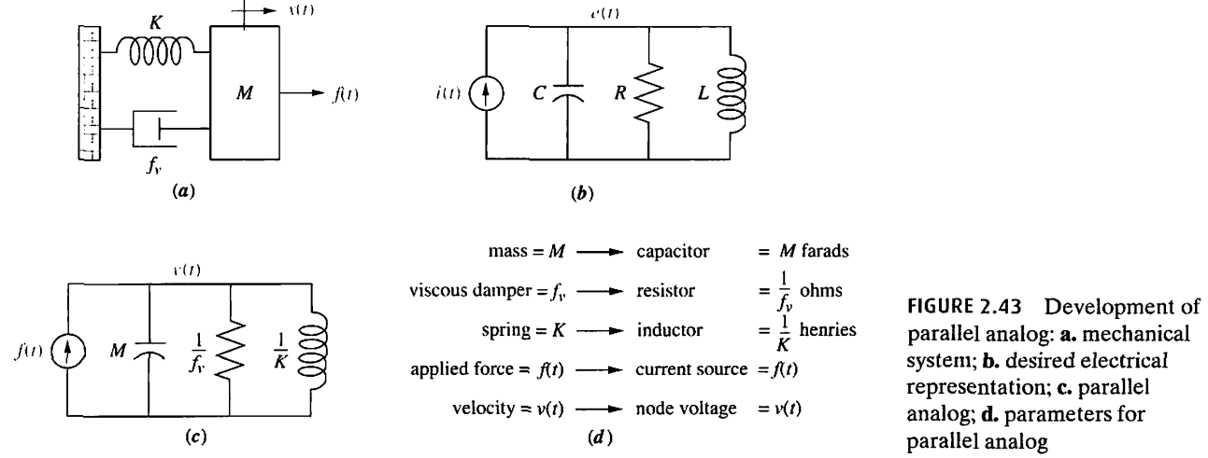
2.10 NONLINEARITIES
+The SYSTEM that CAN be DESCRIBED approximately by (ONLY) LINEAR, Time-Invariant Differential Equation.
+A LINEAR Systems POSSESS 2 Properties : SUPERPOSITION and HOMOGENEITY
+Differences between Linear System and NonLinear System
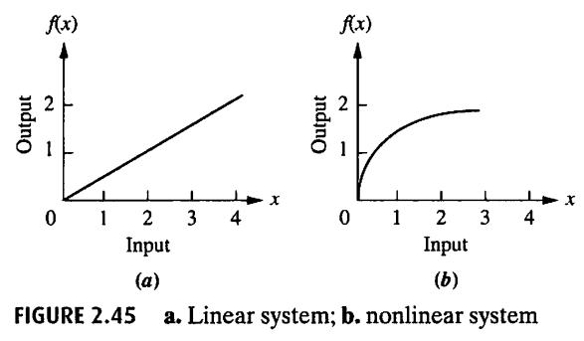
+Some Example for PHYSICAL
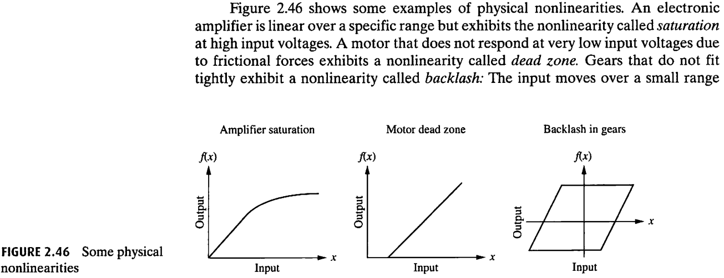
2.11 LINEARIZATION
+We FIND NONLINEAR Components are PRESENT > We MUST LINEARIZE the SYSTEM before we CAN FIND the TRANSFER FUNTION
+EQUILIBRIUM (Keseimbangan), Keadaan Istirahat atau Keseimbangan karena AKSI yang SAMA dengan Gaya Yang BERTENTANGAN.
+The Step LINEARIZATION
- RECOGNIZE the NONLINEAR Component and WRITE the NONLINEAR Differential Equation.
- We TAKE the LAPLACE TRANSFORM of the LINEARIZED Differential Equation
- We SEPARATE the INPUT and OUPUT variables and FORM of TRANSFER FUNCTION
+The STEP FINISHING Linearization
- WRITING NODAL/MESH Equation
- SUBTITUTING satuan yang DIKETAHUI
- LINEARIZE the NONLINEAR Equation
- SUBTITUTING LINEARIZE to EQUATION (2)
- SET nilai yang DIKETAHUI.
- SUBTITUITING nilai yang telah diSET (5)
- FIND the LAPLACE TRANSFORM

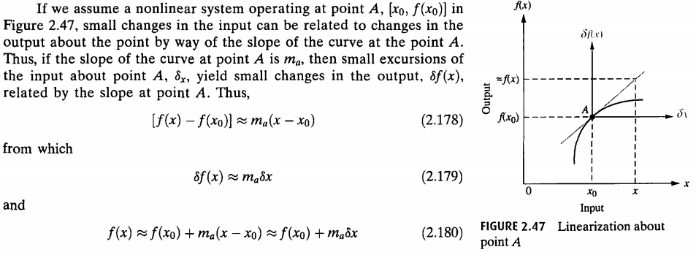

TAYLOR Series Expresses the VALUE of a FUNCTION in terms of the VALUE of that FUNCTION at a PARTICULAR POINT.
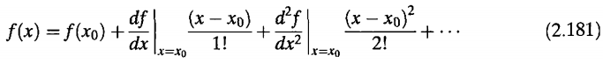

FOR SMALL EXCURSION, the TAYLOR Series can NEGLECT HIGHER-ORDER Terms
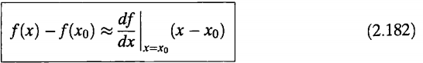
Or
